Shore Families getting together!

The brothers Isaac and Joseph Shore bought Heage windmill in 1850 and they, and their descendents, worked as millers until the mill ceased to operate in 1919. From time to time their many descendents have contacted the mill to try to trace their ancestors and to date this has always been handled on an ad-hoc basis but recently use has been made of an email link involving some eight different branches of the family. The ‘Shores Group’ has therefore been established and any enquiries are pointed to this as a good source of information. The mill has a complete set of census data for Heage and had already identified many of the family but on the female side we have found it more difficult to relate.

As a result of the ‘Group’ we now have a much more complete Shore family tree and if there are more Shores out there contact us at miller@heagewindmill.org.uk in the first instance. We can introduce you into the ‘Group’ and you might just find the information you have been seeking!

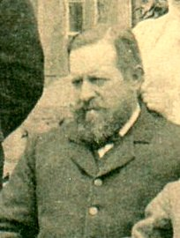
Joseph Smith Shore
in about 1905

