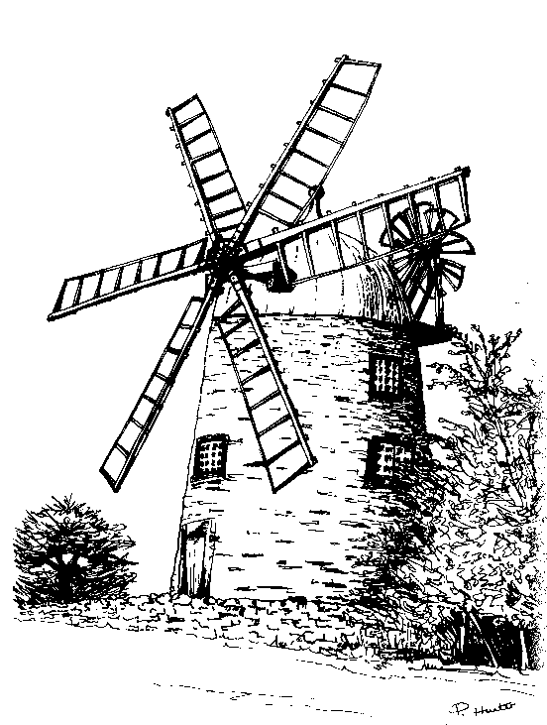
I/We wish to become members of The Friends of Heage Windmill and enclose the appropriate Annual Membership Subscription of:
The Friends of Heage Windmill
Application for Membership 2013

(including free visits to the mill and a quarterly newsletter)

❑ £12.00 (Family - 2 Adult + 2 children)

❑ £7.00 (Ordinary - one person)

❑ £6.00 (Concessionary - OAP, Student)

Please tick the appropriate box.
(Cheques payable to The Friends of Heage Windmill).

Name:........................................................................................................................

Address:....................................................................................................................

........................................................................... Post Code ..................................

Tel No: ............................................... E-Mail: .........................................................

I/We are interested in volunteering to help at the mill as/with:

❑ Miller  Guide  Shop Assistant

❑ Fund Raising  Maintenance work

Please return this form with the appropriate payment to:

Angela Ward
127, Parkside,
Heage,
BELPER,
Derbyshire.
DE56 2AF

